Price Quote for

Item 1:

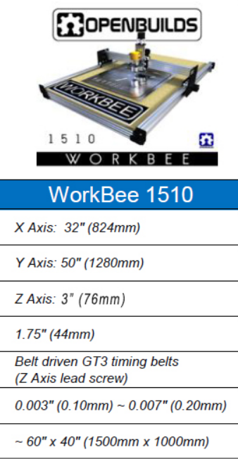

Ext. 2: DRIVER for Step Motor (3x)

ARDUINO MEGA

A-

A+

EN

DIR

PU

STEP MOTEUR

NEMA 23

DRIVER

X

B-

B+

A-

A+

EN

DIR

PU

STEP MOTEUR

NEMA 23

DRIVER

Y Y

B-

B+

A-

A+

EN

DIR

PU

STEP MOTEUR

NEMA 23

DRIVER

Z

B-

B+

PU: Pulse

DIR : direction

In: Movement permission

Bipolar Motor NEMA 23

End of stroke origin (home) of precision, extreme positive limit, extreme negative limit for each axis X, Y, Z.

Power supply for the drives.